TITLE OF THE PROJECT

**MAJOR PROJECT REPORT**

Submitted in partial fulfillment for the award of the degree of

**BACHELOR OF TECHNOLOGY**

**(Computer Science and Engineering)**

Submitted to

**INDIAN INSTITUTE OF INFORMATION TECHNOLOGY**

**BHOPAL (M.P.)**



**Submitted by**

Ankur Chowdhari( 18U03035)

Himanshu Ahirwar(18U02005)

Piyush Singh Rathore(18U02018)

Prince Soni(18U02046)

**Under the supervision of**

Dr. Priyank Jain

Dr. Shalini Stalin

**Month & Year**

May & 2022

|  |  |
| --- | --- |
|  | **INDIAN INSTITUTE OF**  **INFORMATION TECHNOLOGY**  **BHOPAL (M.P.)** |

**CERTIFICATE**

This is to certify that the project report entitled “**HOSTEL MANAGEMENT SYSTEM**”, submitted by **Ankur Choudhary, Himanshu Ahirwar, Piyush Singh Rathore, and Prince Soni** in partial fulfillment of the requirements for the award of the degree of **Bachelor of Technology in** Computer Science & Engineering. The work is comprehensive, complete, and fit for final evaluation.

Date: 22/04/2022

**Dr. Shalini Stalin**

Designation(MENTOR), Department(CSE)

IIIT Bhopal (M.P.)

**Dr Priyank Jain**

MENTOR, CSE

IIIT Bhopal (M.P.)

**Dr. Gagan Vishwakarma**

Major Project Co-ordinator

Computer Science & Engineering

IIIT Bhopal (M.P.)

|  |  |
| --- | --- |
|  | **INDIAN INSTITUTE OF**  **INFORMATION TECHNOLOGY**  **BHOPAL (M.P.)** |

**DECLARATION**

We hereby declare that the following Major Project report entitled “HOSTEL MANAGEMENT SYSTEM” presented in the is the partial fulfillment of the requirements for the award of the degree of **Bachelor of Technology in** Computer Science & Engineering. It is an authentic documentation of our original work carried out under the able guidance of **Dr Priyank Jain**. The work has been carried out entirely at the Indian Institute of Information Technology, Bhopal. The project work presented has not been submitted in part or whole to award of any degree or professional diploma in any other institute or organization.

We, with this, declare that the facts mentioned above are true to the best of our knowledge. In case of any unlikely discrepancy that may occur, we will be the ones to take responsibility.

Ankur Chowdhari (18U03035) Sign of student1

Himanshu Ahirwar (18U02005­­­) Sign of student2

Piyush Singh Rathore(18U02018) Sign of student3

Prince Soni(18U02046) Sign of student4

**AREA OF WORK**

**Software Development** :

* Software development refers to a set of computer science activities dedicated to the process of creating, designing, deploying and supporting software.
* Software itself is the set of instructions or programs that tell a computer what to do. It is independent of hardware and makes computers programmable. There are three types of software-

1. **System software** to provide core functions such as operating systems, disk management, utilities, hardware management and other operational necessities.
2. **Programming software** to give programmers tools such as text editors, compilers, linkers, debuggers and other tools to create code.
3. **Application software** (applications or apps) to help users perform tasks. Office productivity suites, data management software, media players and security programs are examples. Applications also refers to web and mobile applications like those used to shop on Amazon.com, socialize with Facebook or post pictures to Instagram.

**ACKNOWLEDGEMENT**

With due respect, we express our deep sense of gratitude to our respected guide **Dr. Priyank Jain**, for her invaluable support and guidance. We are thankful for the encouragement that she has given us in completing this project successfully. Her rigorous evaluation and constructive criticism was of great assistance.

It is imperative for us to mention the fact that this minor project could not have been without the periodic suggestion and advice of our project co-ordinator **Dr. Gagan Vishwakarma**

We are also grateful to our respected Director **Dr. Narendra Singh Raghuvanshi** for permitting us to utilise all the necessary facilities of the college. Needless to mention is the additional help and support extended by our respected Nodal Officer, **Dr. Meenu Chawla**, in allowing us to use the department laboratories and other services.

We are also thankful to professor in charge examination **Dr. Dheeraj K. Agrawal** who continuously supported and encouraged us by his advices and also helped us in our project presentation that has improved our presentation skills.

We are also thankful to Student Welfare in charge **Dr. Jaytrilok Choudhary** for constantly motivating us to work harder for the completion of the project. We extend our sincere thanks to **Dr. Amit Bhagat** who co-operated with us nicely for smooth development of this project. We would also like to thanks all the other faculty, staff members and laboratory attendants of our department for their kind co-operation and help. Last but certainly not the least, we would like to express our deep appreciation towards our family members and batch mates for providing the much needed support and encouragement.

**ABSTRACT**

As the name specifies “HOSTEL MANAGEMENT SYSTEM” is software developed for managing various activities in the hostel. For the past few years the number of educational institutions are increasing rapidly. Thereby the number of hostels is also increasing for the accommodation of the students studying in these institution. And hence there is a lot of strain on the person who is maintaining the hostel. Since software’s are not usually used in this context. This particular project deals with the problems on managing a hostel and avoids the problems which occur when carried manually. Identification of the drawbacks of the existing system leads to the development of computerized hostel management system that will be compatible to the existing system with the system which is more users friendly and more GUI oriented. We can improve the efficiency of the system, thus overcome the drawbacks of the existing hostel management system. Less human error, strength and strain of manual labor can be reduced.

**TABLE OF CONTENT**

|  |  |  |
| --- | --- | --- |
| **S.no** | **Title** | **Page No.** |
|  | Certificate |  |
|  | Declaration |  |
|  | Area of work | i |
|  | Acknowledgement | ii |
|  | Abstract | iii |
| 1 | Introduction | 1 |
| 2 | Literature review or Survey | 2 |
| 3 | Methodology & Work Description | 5 |
| 4 | Proposed algorithm | 6 |
| 5 | Proposed flowchart/ DFD/ Block Diagram | 7 |
| 6 | Tools & Technology Used | 8 |
| 7 | Implementation & Coding | 9 |
| 8 | Result Analysis | 10 |
| 9 | Conclusion & Future Scope | 11 |
| 10 | References | 12 |

**INTRODUCTION**

Hostel management system is a desktop application for managing hostel records. Hostel management system helps hostel admin in managing records of the hostel in an efficient manner. This project manage records of the students, hostel rooms and other things related to the hostel.

This Hostel Management System is developed in favor of the hostel management team which helps them to save the records of the students about their rooms and other things. It gets rid of the  manual work where it is very difficult to find the record of the students and the information about the ones who had left the hostel years before.

**LITERATURE REVIEW**

**ONLINE HOSTEL MANAGEMENT SYSTEM CHANGWONY, KIPLIMO**

**Summary:**

This paper is about a software developed for managing various activities in the hostel. For the past few years the number of educational institutions are increasing rapidly. Thereby the number of hostels are also increasing for the accommodation of the students studying in this institution. And hence there is a lot of strain on the person who are running the hostel and software's are not usually used in this context. This particular project deals with the problems on managing a hostel and avoids the problems which occur when carried manually. Identification of the drawbacks of the existing system leads to the designing of computerized system that will be compatible to the existing system with the system which is more user friendly and more GUI oriented. We can improve the efficiency of the system, thus overcome the drawbacks of the existing system . . less human error · Strength and strain of manual labor can be reduced · High security · Data redundancy can be avoided to some extent · Data consistency · Easy to handle · Easy data updating · Easy record keeping · Backup data can be easily generated

**URI:** [Http://Hdl.Handle.Net/123456789/2059](http://hdl.handle.net/123456789/2059)

**Date:** 2015-04

**HOSTEL MANAGEMENT SYSTEM**

**EMMANUEL ADU BAFFOE JUNE**

**Summary:**

This paper is on “ONLINE HOSTEL MANAGEMENT SYSTEM” which  is a software developed for managing various activities in the hostel. For the past few years the number of educational institutions is increasing rapidly. Thereby the number of hostels is also increasing for the accommodation of the students studying in this institution. And hence there is a lot of strain on the person who are running the hostel and software’s are not usually used in this context. This particular project deals with the problems on managing a hostel and avoids the problems which occur when carried manually. Identification of the drawbacks of the existing system leads to the designing of computerized system that will be compatible to the existing system with the system which is more user friendly and more GUI oriented. We can improve the efficiency of the system, thus overcome the drawbacks of the existing system.

**Date:** 2016-06-15

**URI:** <http://hdl.handle.net/123456789/425>

**DESIGN INFORMATION SYSTEM FOR UNIVERSITY OF DUHOK HOSTEL**

**AUTHOR :-                                      .**

Chiai Muhammad haji Al-Atroshi

Dina Rafaa

**Summary :**

This paper suggests a hostel management information system that can be used to administer University of Duhok Hostel. It shows the proposed database tables, user interfaces and functions required for this purpose. This information system will be used to manage the hostel rooms, floors, and various events.there is a lot of pressure on the person running the hostel as no special software or database are usually used in this context. This paper explores the drawbacks of the existing system and the requirements for designing a new computerized and more user friendly and graphical user interface (GUI) oriented system.

**Published:** 24-01-2021

**Link:** <http://journal.lfu.edu.krd/ojs/index.php/qzj/article/view/443>

**PROPOSED METHODOLOGY AND WORK**

**DESCRIPTION**

The **methodology** adopted for this project is object oriented methodology (OOP).We live in a world of objects, these objects exist in nature, in man-made entities, in business, and in the products that we use. They can be categorized, described, organized,combined, manipulated and created.

Checking the room’s availability, allocating room to new students, managing hostel fees records and all such hostel management related activities manually that consumes efforts, time, and resources. Moreover, hostel management also requires looking after the security of students which can only be achieved with close supervision of daily student’s activities.

Hostel management system is designed to manage all hostel activities like hostel admissions, fees, room allotment and related things. It is also used to manage monthly mess bill calculation, hostel staff payroll, student certificates, etc.

Designed & developed keeping in mind all the hostel management concerns of staff, MasterSoft's Hostel Management Software is a one-stop-solution for higher education institutions. Right from students' registration to allocating rooms & mess, managing student count records, and ins-and-outs of students, it streamlines & automates all the day-to-day hostel activities.

**It also ensures the following details to be fed for effective management.**

* Hostel infrastructure
* Registered students
* Room allotment
* Fines and Payroll

**TOOLS AND TECHNOLOGY**

**USED**

Tech Stack -

* **Python** :- Fast and easy to learn language.
* **Tkinter (for GUI)** - Tkinter is a Python binding to the Tk GUI toolkit. It is the standard Python interface to the Tk GUI toolkit, and is Python's de facto standard GUI.
* **Pillow(PIL Python Library)** :- Python Imaging Library is a free and open-source additional library for the Python programming language that adds support for opening, manipulating, and saving many different image file formats.
* **VS Code (IDE)** :- User Friendly.
* **MySql (Workbench)**:- As back-end programming languages to fulfill the requirements of our Software.

**Proposed Algorithms**

**Proposed Flowchart/ DFD/ Block Diagram**

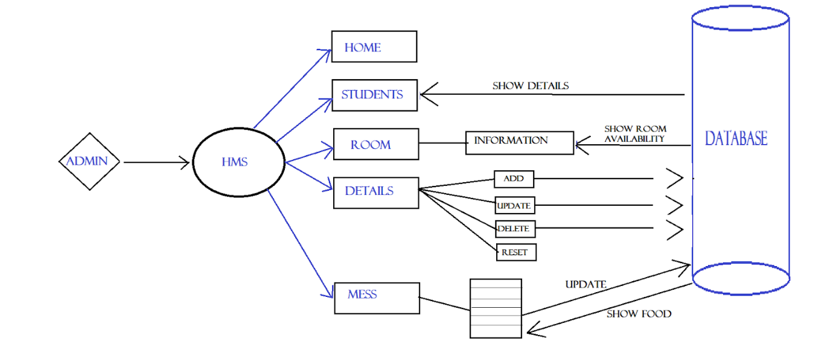

**IMPLEMENTATION AND CODING**

**RESULT ANALYSIS**

**CONCLUSION AND FUTURE SCOPE**

The conclusion of this project is that the admin will invest less time for managing student records as it is completely computerized and addition updation and searching of students records is much more easier and efficient than previous methods. It is cost efficient as only software development cost is there and no additional cost such as pages,registers etc are not needed and it makes the data highly secure  and reliable.

**REFERENCES**